Title (Calibri, bold, 18 pt, single space)
<1 line spacing >
<for the review version please delete the names and affiliations>
Name, Familyname (if corresponding author add email)^{1,2}
John, Smith ² (john.smith@cerc-conf.eu) <Calibre 12pt, single space>

<1line spacing>
¹ University1, Address, Country <Calibre, 10pt>
² ATU, Galway, Ireland

<4 line spacing >

Abstract (Calibre, bold, 14pt)

<1 line spacing>
The Abstract is a brief summary of the entire paper, capturing the main purpose, methods, key findings, and conclusions. It should be written in Calibri, 12 pt font, with the text fully justified for a neat and professional look. The abstract must not exceed 150 words to maintain clarity and focus. This section helps readers quickly understand the paper’s scope and significance without reading the full text. Writing a clear and concise abstract is essential for effective communication of your research.

<1 line spacing>
Keywords: Keyword 1, Keyword 2, Keyword 3, Calibre 12pt font (4 keywords max)

<2 line spacing>
Introduction (Calibri 12pt bold, no numbering)
Writing a conference paper is an essential skill for researchers aiming to share their findings with the academic community. A well-structured paper not only communicates your work clearly but also highlights its significance and originality. Typically, a conference paper follows a logical flow through several key sections, each serving a distinct purpose.
You might begin with an Introduction that sets the context, states the problem, and outlines the paper’s objectives. Next, the Related Research section reviews existing work, positioning your contribution within the broader field. The Method section details how your research was conducted, providing enough information for reproducibility. Following that, the Results section presents your findings clearly and concisely, often with tables or figures. The Discussion interprets these results, exploring their implications, limitations, and potential for future work. Finally, a Conclusion summarizes the main points and underscores the paper’s contribution.
This structure guides readers through your research journey, making your insights accessible and impactful.

<1 line spacing before the section heading and subheading, no line spacing after the heading and subheading >
Details of the Paper/Extended Abstract
For this conference, full papers must be comprehensive yet concise, with a length of 10 pages, including the reference list. This page limit ensures that authors provide sufficient detail to explain their research thoroughly while maintaining readability and focus.

<1 line spacing before table/figure/illustration>
Table 1: Title (Calibri, Italic, 12 pt, centered)
Type of paper | Max. pages | Max. no. of words
Full paper | 10
Extended abstract | 2 | 1000

<1 line spacing after table/figure/illustration>
In contrast, extended abstracts are designed to offer a brief overview of the work and are therefore limited to 2 pages and no more than 1000 words. Extended abstracts should succinctly present the core ideas, methodology, and key findings without the depth and extensive discussion expected in full papers, see Table 1.

____________________________________________________________________
©️ 2026 Copyright for this paper is by its authors.
Use permitted under Creative Commons License Attribution 4.0 International (CC BY 4.0).
Proceedings of the CERC 2026 Conference 16-17 October, Galway, Ireland

Page Layout and Numbering
The paper must adhere to specific margin settings to ensure a clean and professional appearance: top margin of 3 cm, bottom margin of 2 cm, and left and right margins of 3 cm each. Authors should not include page numbers in their submissions, because page numbers will be added later during the compilation of the conference proceedings. This approach ensures consistent pagination across all papers in the final published volume.

Formatting of Subheadings and Text (Calibri, italics, 12 pt)
Subheadings should be formatted in Calibri, 12 pt, italics, and without numbering. This style helps differentiate sections clearly while maintaining a clean, professional look.
The main text must use Calibri, 12 pt, and be justified to create a neat block of text on each line. Paragraphs should not be indented, allowing for clear separation through spacing instead, which enhances readability and visual flow throughout the paper.

Include one blank line before each section heading and subheading. After the heading or subheading, do not add any extra blank lines; the text should begin immediately. This formatting creates a clear visual separation above the headings while keeping the content closely connected below, improving readability and saving space.
Text Formatting Restrictions
To maintain a clean and uniform appearance throughout the conference papers, no bold, italics, underlining, or other special text formatting are allowed within any sections of the main text. This rule helps ensure consistency and readability, allowing the content to speak clearly without distractions from varied styles.

Use of Bold Text in the Template
Bold text has been used selectively in the template to highlight key terms and important instructions. This helps guide authors’ attention to critical formatting rules and essential elements without overwhelming the overall presentation. By emphasizing only the most relevant points, the template supports clarity and ease of use while maintaining a clean and professional look.

Tables and Figures
Tables and figures should be integrated within the relevant sections of the paper rather than placed at the end. Embedding these visual elements close to the text that discusses them helps readers follow your arguments more easily and enhances the clarity of your presentation. Proper placement ensures a smooth flow of information and makes your findings more accessible and impactful.

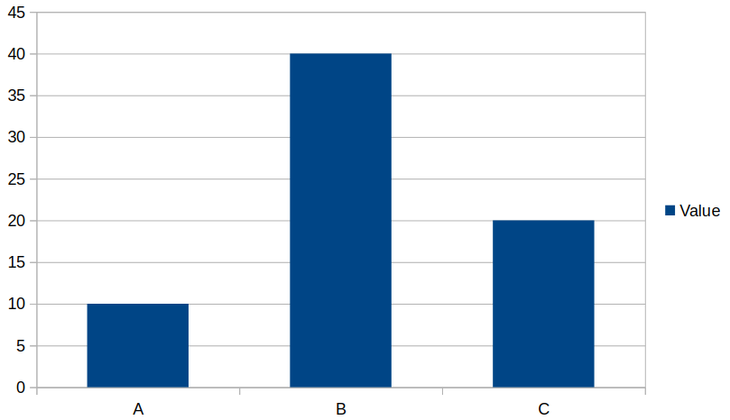
Figure 1: Example (Calibri, Italic, 12 pt, centered)

All figures, tables, and illustrations must be included in the main text, numbered, and captioned. They should be centered on the page. Captions for figures should be placed below the image, while captions for tables should appear above the table, both in italics. For examples, see Table 1 and Figure 1.

All diagrams must include a clear and concise legend that explains the symbols, colors, or patterns used. Legends should be placed within or directly adjacent to the diagram to ensure readers can easily interpret the visual information. A well-crafted legend enhances understanding and makes your diagrams more accessible and effective in supporting your arguments.

All tables and figures must be clearly referenced at the appropriate point in the text where they are discussed. This ensures readers can easily connect the visual information with your analysis, supporting a coherent and logical flow throughout the paper. Always use consistent labels such as “Figure 1” to guide the reader directly to the relevant illustration.

Final Submission Guidelines
To ensure a fair and unbiased review process, the initial submission must be completely anonymous, with no author names or identifying information included in the file.
If the paper is accepted, the clearly referenced at the appropriate point clearly referenced at the appropriate point second (final) submission must follow the same template and formatting guidelines outlined above. However, authors should include the name(s) of the author(s) immediately after the title, as indicated at the beginning of the template. This ensures proper attribution and consistency in the final conference proceedings.
Please note that all submissions must be provided in PDF format only to guarantee consistent formatting and ease of review.

Referencing Style
This paper requires the use of the Harvard referencing style with full bibliographical details to ensure clarity, consistency, and academic integrity. Proper referencing allows readers to trace the sources of information and ideas, supporting transparency and scholarly dialogue.
All statements, data, or ideas that are not original to the authors must be properly referenced to acknowledge the original work and avoid plagiarism.
For detailed guidance on Harvard referencing, please visit MyBib (n.D.) and select “Harvard”.

Reference List
At the end of the paper, list all references in alphabetical order by the authors’ last names. Please ensure that full bibliographical details to ensure clarity, consistency, and academic integrity. Proper referencing allows readers to trace the sources of information and ideas, supporting transparency and scholarly dialogue.
All statements, data, or ideas that are not original to the authors must be properly referenced to acknowledge the original work and avoid all references are included within the 10-page limit of the paper. This organized approach helps readers easily locate sources and maintains a professional, consistent presentation.
The reference list should be formatted in Calibri, 10 pt, and justified. This ensures a neat and consistent appearance that complements the main text while keeping the references clear and easy to read.

References
MyBib. (n.d.). FREE Cite Them Right Harvard Referencing Generator [Updated For 2020]. [online] Available at: https://www.mybib.com/tools/harvard-referencing-generator/cite-them-right. (last accessed 13.04.2026).

Blasi Casagran, C. (2023) ‘AI developments and emerging tech laws in the current digital era’, in Proceedings of the CERC 2023 Conference. Edited by H. Afli et al. CERC Conference , Darmstadt: University of Applied Sciences Darmstadt. Available at: https://cerc-conf.eu/proceedings/CERC2023_proceedings.pdf (Accessed: 14 April 2026).

